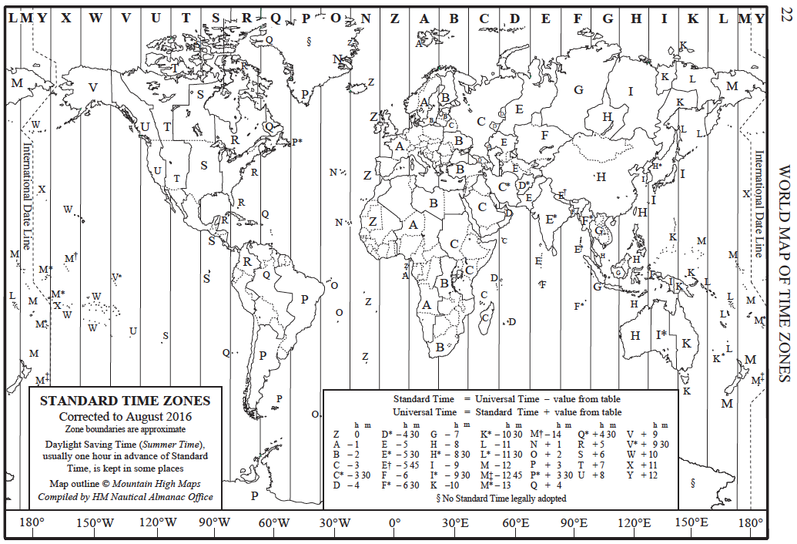

**QUESTION ONE**

(6 marks)

Using the time zone map, complete the following table to show the local time that Brendan must initiate a phone call to his mother in PERTH so that he calls her at 7pm PERTH time. He needs to call her at least once from each city that he visits during his round the world trip.

|  |  |  |
| --- | --- | --- |
| **City** | **Local time in city** | **Time in Perth** |
|  |  | 7:30 pm. |
|  |  | 7:30 pm. |
|  |  | 7:30 pm. |
|  |  | 7:30 pm. |
|  |  | 7:30 pm. |
|  |  | 7:30 pm. |

**QUESTION TWO**

(12 marks)

Using your information from your home work, complete the following table showing the currency exchange for six of the countries that you have proposed to Brendan.

|  |  |  |  |
| --- | --- | --- | --- |
| Country | Currency Abbreviation | Cost in AUD for 100 or 1000 (delete as appropriate) of the local currency. | AUD100 converts to how many of the local currency? |
|  |  |  |  |
|  |  |  |  |
|  |  |  |  |
|  |  |  |  |
|  |  |  |  |
|  |  |  |  |

**QUESTION THREE**

For six of the flights that you have proposed, complete the following table:

(24 points)

|  |  |  |  |  |  |  |
| --- | --- | --- | --- | --- | --- | --- |
| Start city (give time zone) | End city  (give time zone) | Start time (give time zone) | End time (same time zone as start time zone) | Flight time (h:m) | Flight distance (km) | Average flight speed (km/h) |
|  |  |  |  |  |  |  |
|  |  |  |  |  |  |  |
|  |  |  |  |  |  |  |
|  |  |  |  |  |  |  |
|  |  |  |  |  |  |  |
|  |  |  |  |  |  |  |